Having coaching

conversations with

your patients with

long-term conditions

One-day workshop

Thank you

For what you do.
For what you are going to do in the future.

Outcomes
By the end of this workshop you will have:
- described the conversations you are currently having with people with long-term conditions about their goals
- understood how you can improve these conversations
- described the communication skills needed for coaching conversations
- practised having coaching conversations with patients with long-term conditions about their goals
- considered how the patient’s goals are recorded for the patient and the health team
- identified how you and the patient can keep patient goals as a priority.

What’s your patient’s story?

Does this patient have a written care plan? | Yes / No
Does this patient have a copy of the care plan? | Yes / No
Do you know what is important to this patient? | Yes / No

2

Who’s inside and outside your patient’s social network?

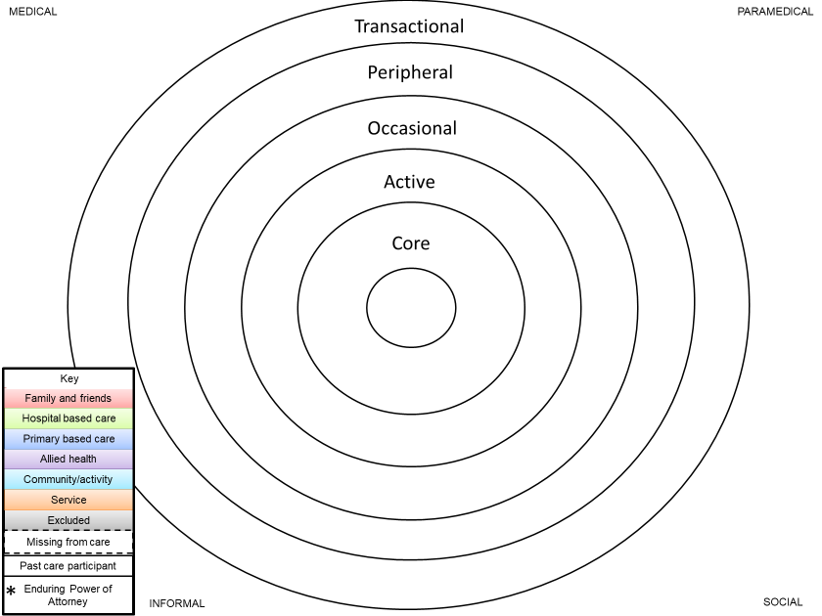

© Jessica Young, June 2017. You are welcome to share this resource but please attribute to the author. Contact: jessica.young@otago.ac.nz

Current conversations

Mark this diagram showing your current conversations with patients about goals.
What do you speak about first, in the middle, at the end?
Who speaks most?

You speaking

Patient speaking
1 2 3 4 5 6

Health literate conversations

v
Asking questions

Listening

1. Ask
(Find out what people know, think, do and believe
2. Build
(on what people already know)

3. Check
(that you have been clear)

Ask really good questions – you are not the police but you are a detective

“Tell me” turns every question into an open question.
“Tell me how you have been since I saw you last.”
“Tell me about the goals you are working towards.”
“Tell me about your care plan that you have written with people at your GP practice.”

We have two ears and one mouth so we can listen twice as much as we speak

Epictetus

“Most people do not listen with the intent to understand;
they listen with the intent to reply.”
(Stephen R. Covey: 1932-2012)

Listening to reply | Listening to understand
Rehearsing your answer | Paying attention and checking understanding

Keep on listening, don’t think about your reply.
Reflect back to check you understand.
“I think you are saying …”
“Losing weight is hard, even though you know it is better for your health.”

Tips
Ask yourself:  Who is doing most of the talking in this conversation? | Remember, wait and give the person time to finish before you start talking again.

We know you work hard -

this is about working smarter

At Step 1 you find out what people think about their health.
Remember, their health might be more important to you than it is to them.

Explore health beliefs
“What do you think about …?”
“How does your situation make you feel?”
“Tell me how you feel about …”
“Different people react differently to finding out about … How did it make you feel?”
“What do you think about taking medicines for your long-term condition?”

Page 21: Take Charge Workbook

Whose decision is it anyway?

Forcing a round peg into a square hole takes a lot of effort on your part and does a lot of damage to the peg as well.
What do you do to make sure your patient makes the decision, and not you?

What is the motivation for change?

Remember, motivation and what is important to people are linked

What is good about:
  - Staying the same?
  - Making a change?
What is the worst thing that could happen?
What has motivated some of your patients to make a change?

Change ruler

Imagine a scale of 1-10, where 1 is not important and 10 is very important
1 | 2 | 3 | 4 | 5 | 6 | 7 | 8 | 9 | 10

You use the change ruler in two situations:
1. To assess the importance to people of making changes to achieve their goals. Ask them:
“So, on a scale of 1-10 how important is it to you to make changes to achieve your goal?”
And when they answer then you ask a 'backwards' question "So why are you at a 5 and not a 1?"
When you are talking about importance you need to go backwards so people then tell you the reasons WHY they need to make a change.
If you ask people a 'forward' question "Why are you at a 5 and not a 7?" then the people will give you all the reasons to stay the same and not make any changes.
2. To assess people’s confidence in making changes so they achieve their goal.
Ask "So, on a scale of 1-10 how confident are you that you can make the changes to achieve your goal?”
People’s confidence levels really need to be at a 7 as an indication that they have the ability to make the changes.
So, if they are under 7 ask a 'forward' question "What would it take for you to be a 7?" Don’t force people to increase their confidence to a 7. Instead make the action plan/goal smaller or break it down more e.g. “go to bed at 10pm 3 nights a week” rather than 5 nights a week. Or “sleep 8 hours at night for 3 days” rather than go straight to 9 hours per day.

Goal setting

What is important to you?
“What do you want to do?”
“When will you do it?”
“How often will you do it?”
“Who can support you with this?”

Set people up to achieve success

S
E
S
  - Find something they have been successful at.
  - How did they know they were successful? What was the evidence?
  - What strategies did they use?

They are already climbing a small hill, don’t make it a mountain

Work with the patient’s existing goals. Don’t add new goals and new tasks so that patients are not sure what to do about the different and competing demands.

Pages 8-14: Take Charge Workbook

Follow up

Always, always follow up

“How has it gone since I saw you last?
“Tell me what went well.”
“What is getting in the way?”
“What could make you more confident?”
“What have you done to reward yourself for being successful?”
“What else can I do to support you?”
And make sure you follow up with the people who are doing well. Ask about extending their goal or challenging them to achieve what is important to them.

Catch people doing something well, even if you have to look really really hard

Houston, we have a problem

Solving problems when patient isn’t achieving their goals
“Tell me what is stopping you …”
“What might help you to …?”
“How else do you think you could do this?”
“What other ideas do you have?”
“What else could we be missing?”
“How have you managed something like this before?”
“What are the pros and cons of doing that?”
“Which one do you want to start with?”
“If there was one thing on this list …?”
If necessary, review action plan process/goals.
Use change ruler to re-assess importance/confidence.
“Okay, so there is a bit of difference here – anything that you think you could change to make this happen?”
Deliver specific support for specific issues. Coach people to help themselves.
Problem-solving process:
1. Identify and define problem.
2. Quickly think up some ideas.
3. Rate each idea.
4. Choose one idea.
5. Put this idea into action.
6. If it doesn’t work, try another idea on the list.

Pages 28-29: Take Charge Workbook

Change

If you wanna make the world a better place
Take a look at yourself and then make a change
Michael Jackson

What is one thing you are good at?
………………………………………………………………………………………………………………………………………
………………………………………………………………………………………………………………………………………
What is one thing you are going to commit to change as a result of today?
………………………………………………………………………………………………………………………………………
………………………………………………………………………………………………………………………………………
Strategies you will use to achieve this change.
………………………………………………………………………………………………………………………………………
………………………………………………………………………………………………………………………………………
………………………………………………………………………………………………………………………………………
………………………………………………………………………………………………………………………………………
And thank you again

Page 11: Take Charge Workbook

