HEALTH & DISABILITY COMMISSIONER
TE TOIHAU HAUORA, HAUᾹTANGA

Going to hospital
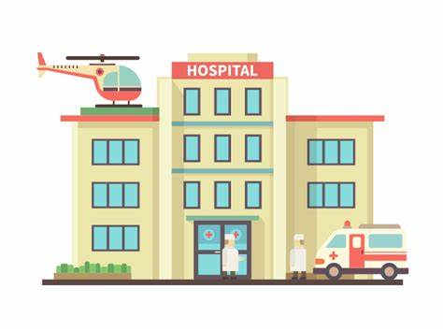

Easy Read booklet about:

- what will happen when you go into hospital

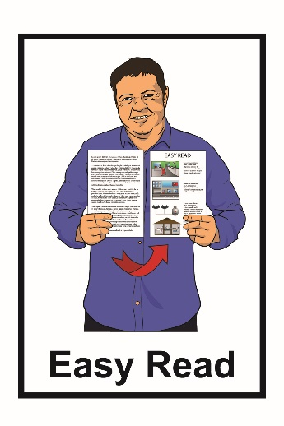
- how to be ready for a hospital visit.

What you will find in this booklet

Page number:

Going to hospital 4

Support needs 5

What to think about 6

At the hospital 10

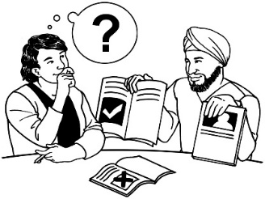

Consent 11

Page number:
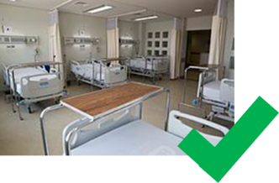

Hospital admissions 13

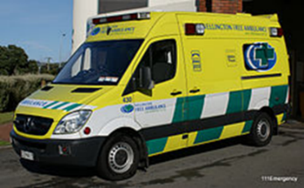

Emergency and unplanned
admissions…………………………..17

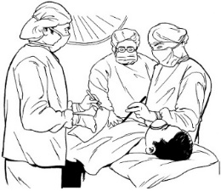

Surgery 20

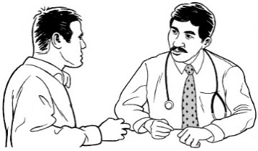
Day clinics and specialist
services 23

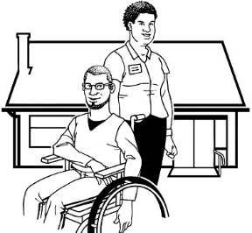

Discharge from hospital 25

Page number:

Questions and answers 28

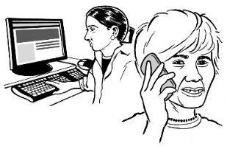
Contacts 35

Information about your rights 43

Going to hospital

You may go to hospital if you:

            - are not feeling well
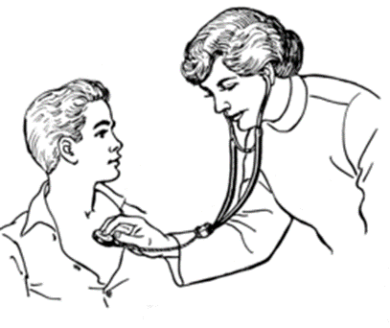

            - have been hurt

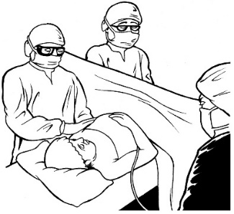
            - need surgery

            - have to see a specialist

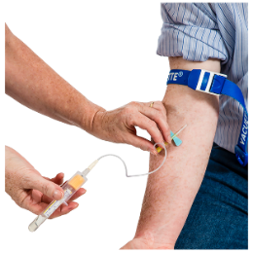
            - have to go to a day clinic

            - have to have tests.

This booklet has information about what can happen when you go to hospital.

Support needs

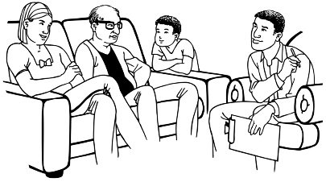
Sometimes people need support when they go to hospital.

Everyone can have a person to support them.

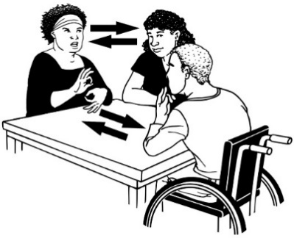
Some of the kinds of support you can have are:

- to have an interpreter if you are Deaf
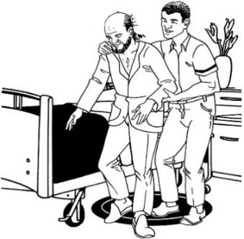
- to have someone to support you to move around if you find it hard to walk
- to have someone to support you with understanding the information.

What to think about

When you know you are going to hospital you can take things with you.

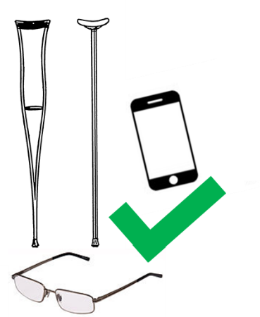
Some things you can bring with you are:

- walking sticks
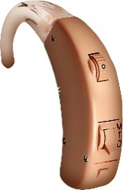
- a wheelchair
- glasses
- hearing aids
- phone with your charger and phone numbers of people to contact
- clothes.

Some other things you can bring to hospital with you are:
- toiletries like soap
- a book or magazine.

Hospitals will tell you what you should not bring.
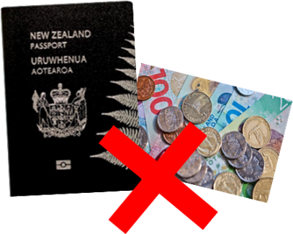
Some things you should not bring are:
- passports
- jewellery
- a lot of money.

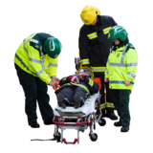
Sometimes you may become unwell fast.

You may need to get to the hospital quickly.

You may want to plan so you can still take some important things with you like:

- your My Health Passport

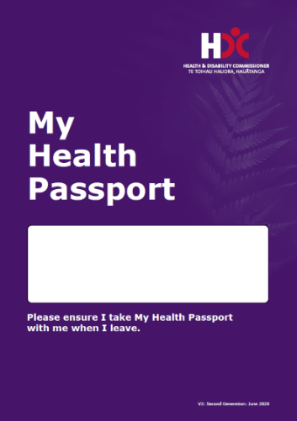
- a Life Tube.
My Health Passport is a document that has information about:

- your support needs in hospital
- contact details for your family.

You can get a My Health Passport from the Health and Disability Commissioner.

You can find out how to contact the Health and Disability Commissioner on page 35 of this booklet.

The Life Tube is something you keep in your fridge with information about your medication.

You can get a Life Tube from Age
Concern.
You can find out how to contact Age Concern on page 34 of this booklet.

At the hospital

When you are at the hospital you will be told why you are in hospital.

You may be asked a lot of questions.

This is so people can support you.

Hospital staff will ask you to decide about your care and treatment.

You can ask someone you trust to support you to decide.
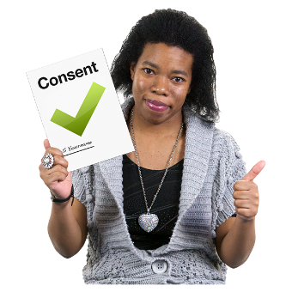

Before anything can happen to you the hospital will ask you to give consent.

Consent

Giving consent means you say yes to care and treatment.

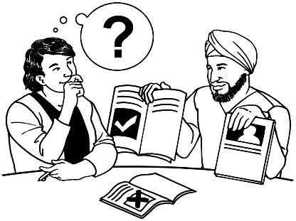
To give your consent you need to be told all the information in a way that you can understand.

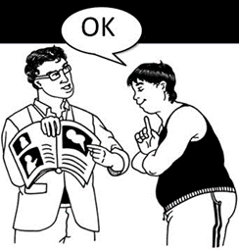
You can give consent:
- by talking
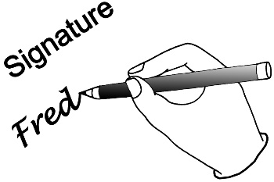
- by writing
- by your actions.

You can change your mind at any time.

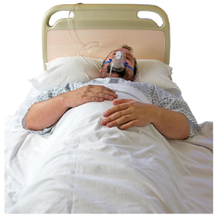
If you cannot give consent then someone else will make the decision for you.

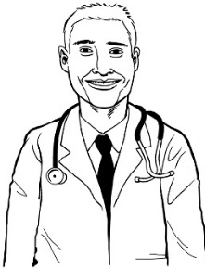
The person who makes decisions for you may be:
- a doctor
- your guardian
- a family member
- your Enduring Power of Attorney.

A guardian has been given the role of making decisions for you.

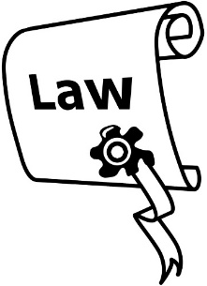
An Enduring Power of Attorney is a legal document.

This means someone else can make decisions for you if you cannot.

Hospital admissions

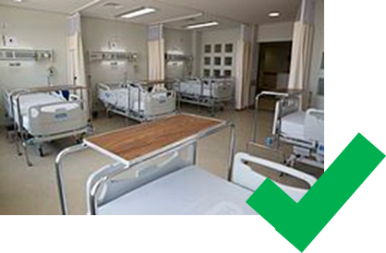
Going into hospital for care or treatment is called:
- being admitted
- an admission.
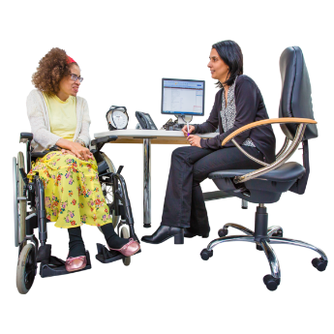

Your doctor may say that you need to be admitted to the hospital for care or treatment.
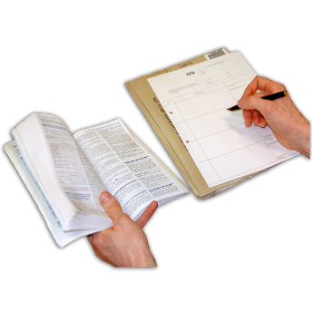

Your doctor will send a letter to the hospital.

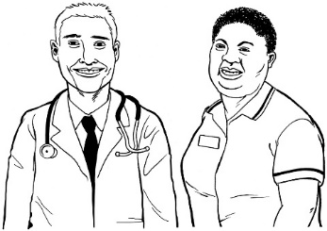
The hospital staff you will see when you are admitted are called the admissions team.

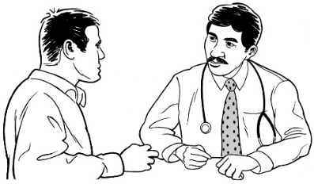
The admissions team will talk with you about your hospital stay.

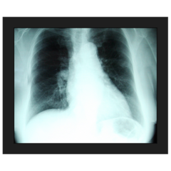
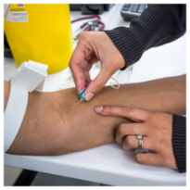
The hospital may ask you to:
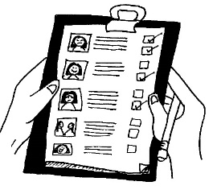
- have tests done like blood tests or X-rays
- fill out forms
- not eat or drink for some time.

When you get to the hospital the admissions team will check your:
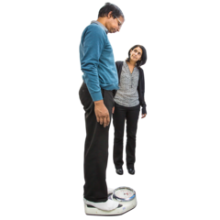
- name
- age
- weight
- contact details.

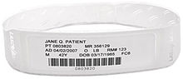
The hospital will give you a wristband to wear.

The wristband will tell the hospital who you are.

It will have information about you like:
- your name
- when you were born
- your address
- your National Health Index Number.

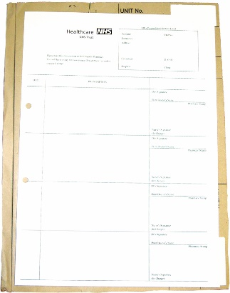
A National Health Index Number is a hospital number every person has.

Your National Health Index Number is linked to your medical information.

Emergency Department and
unplanned admissions

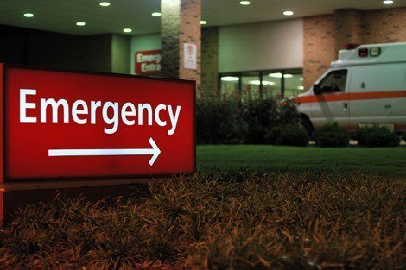
You will go to the Emergency Department at the hospital if:
- you get sick quickly
- you hurt yourself.

The Emergency Department is also called ED.

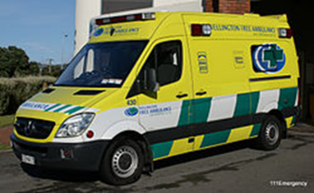
You may:
- go in an ambulance
- have a friend or family member drive you.

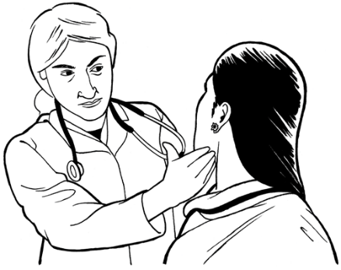
At ED a nurse will meet you and triage you.

Triage means a nurse will look at you and decide how quickly you need help.

If you are very sick or hurt badly you might see a doctor first.

ED can be:
- noisy
- busy.

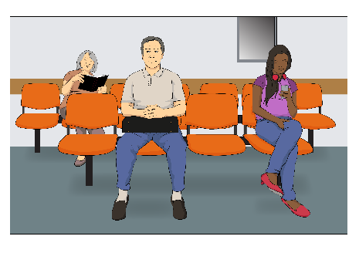
You may have to wait a long time in ED.

You may be moved around the hospital to different places.
An ED doctor might look at you then decide:
          - to treat you and discharge you

          - to send you to an outpatient clinic for more tests

          - to admit you to a ward for more treatment and care.
Discharge means you can leave the hospital.

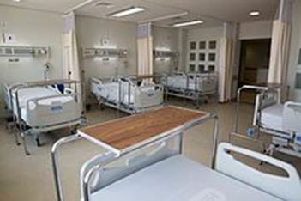
Outpatient clinic means you get treatment but you do not stay in the hospital.

Admit means you have to stay in the hospital for some time.

This could be for hours or overnight or longer.

Surgery

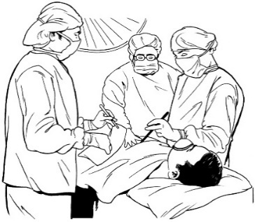
Surgery happens when a doctor cuts into you to:

- take away part of your body
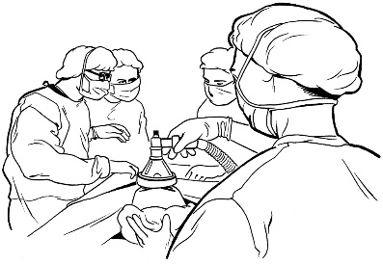
- fix a part of your body.

Surgery is sometimes called an
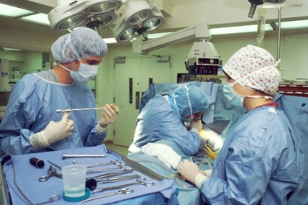
operation.

You may meet a lot of people when you have surgery.

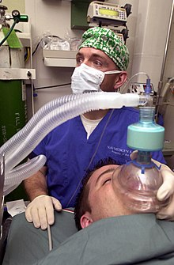
One of these people will be an anaesthetist.

An anaesthetist is a doctor who supports you through surgery by making sure you:
- have medicine to keep you asleep
- do not feel any pain during surgery.

Before surgery you will :
- be told a lot of information
- have to fill out forms.

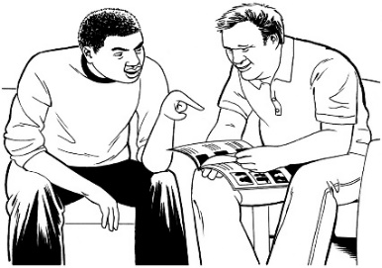
You can ask for support to understand what is going to happen.

On the day you have surgery you may:

- be told not to drink or eat anything

- wear a hospital gown

- take off things like your glasses or hearing aids

- have a needle with a tube in it put into your arm so you can be given medicine
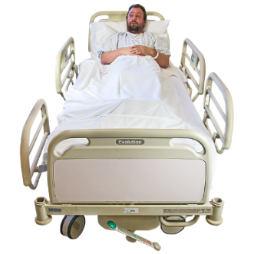

- be moved to a different room for the surgery.

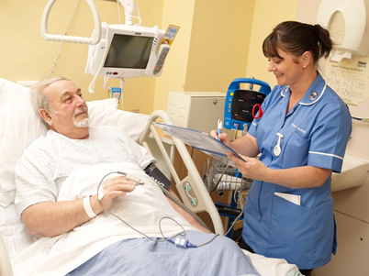
After surgery you will move to another room where nurses will look after you to make sure you are ok.

Day clinics and specialist services

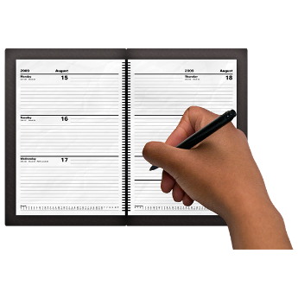
Day clinics and specialist services are appointments at the hospital.

A specialist is a person who has lots of training in 1 kind of medicine.

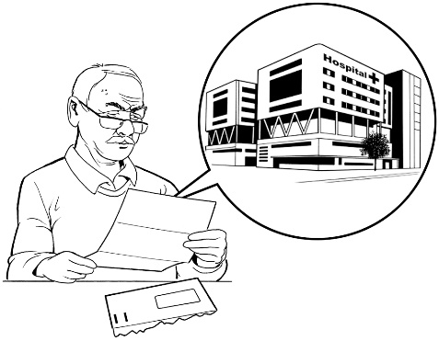
You may be referred to a day clinic or specialist service.

Being referred is when a doctor or other people in the hospital will make you an appointment with the clinic.

You can go to these as an outpatient.

Being an outpatient means you do not need to be admitted to the hospital.
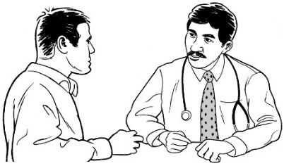
These appointments can happen before or after a surgery.

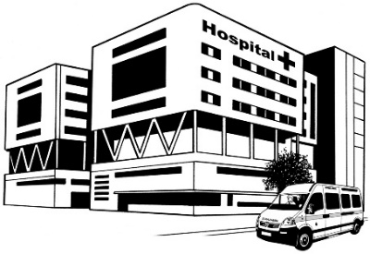
For some appointments you will have to travel to a different hospital.

Discharge from hospital

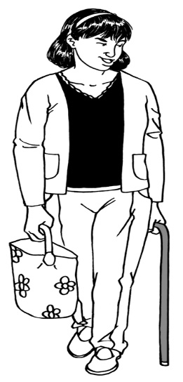
When hospital staff have treated you they will decide when you are ready to leave the hospital.

Leaving the hospital after treatment is called being discharged.

When you are discharged it is important that you know what to do next.

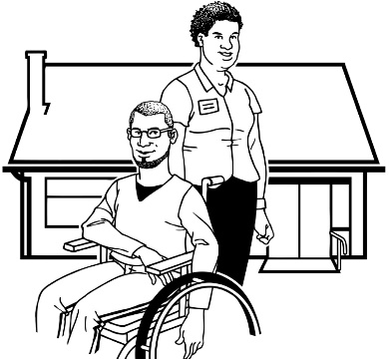
You may need:
- some support to live in your home

- other treatment through an outpatient clinic
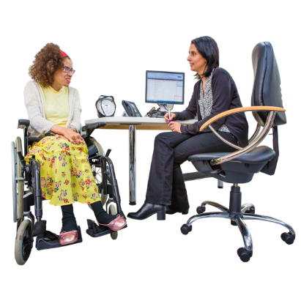

- to see your doctor

- to change your medicine

- to do exercises to help you get better.

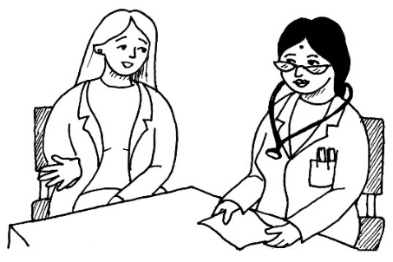
The hospital staff will talk with you about this before you leave the hospital.

Before you leave the hospital it is important that you:
- have someone to drive you home
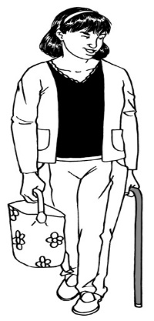
- have any equipment that you need

- have a plan for getting any medicine you need

- take all of your stuff with you like your My Health Passport

- know what to do if you get sick or hurt yourself again.

Questions and answers

These are answers to some questions you may have about being in hospital.

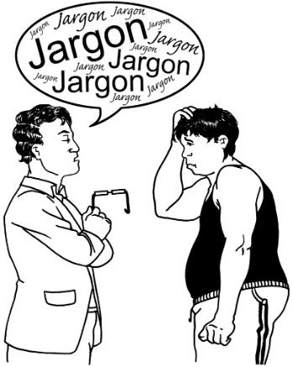
- What if I do not understand what the hospital is saying?

- Tell someone that you do not understand.
- Ask them to use different words.

- Ask to have a support person to help you to understand.

- What if there are foods I can not eat?

- Tell a nurse about it.
- The nurse will make sure you get the right food.

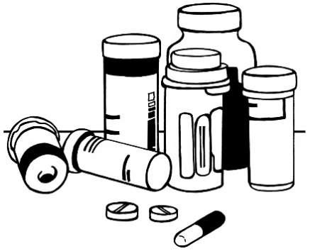
- What if I have a question about my medication?

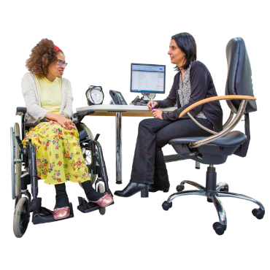
Ask your nurse or a doctor or a pharmacist to explain:
- the medicine
- the side effects it has.
Side effects is what happens to a person when their body does not like the medicine.

- I need support to get to my appointments after I am discharged.
A hospital social worker may be able to support you to get this.

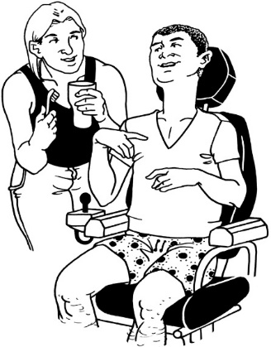
- I need support when I go home

A hospital social worker can support you to make sure you get support at home.

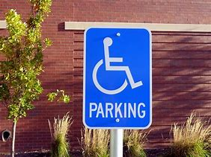
- Is there mobility parking?

All hospitals have mobility parking.

Ask the hospital about this.

- When can people visit me in hospital?

Every hospital has different rules about visitors.

The hospital website should have information about when people can visit.

- Can I have an interpreter?
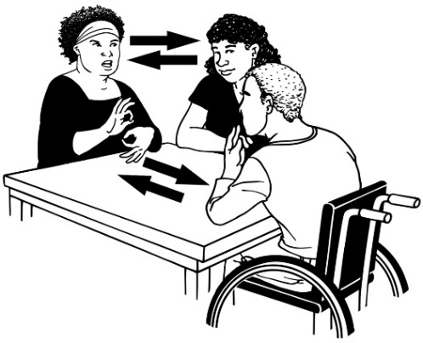
Yes you can have an interpreter.
Make sure you ask the hospital to organise an interpreter for you.

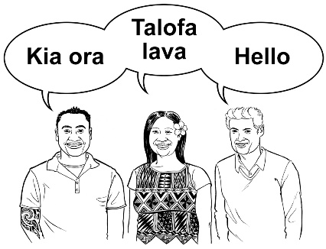
An interpreter is someone who tells people what someone is saying when they speak a different language.
- Do I have to pay?

Most things in hospital are free if you are a New Zealand:
- citizen
- permanent resident.

A New Zealand citizen is someone who can get a New Zealand passport.

A permanent resident is someone the government has said can stay in New Zealand for as long as they want.
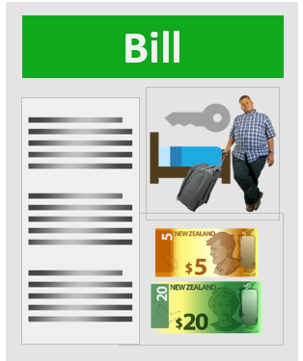

If you have to pay you will be sent a bill from the hospital.

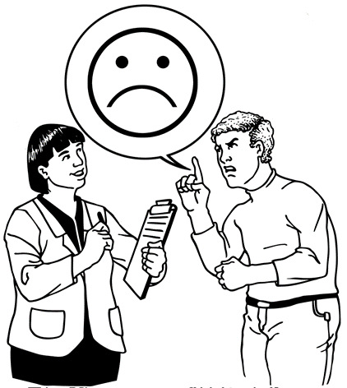
- What can I do if I am not happy with a health service?

Talk to your support person or to a nurse.
Ask to talk to a hospital social worker about it.

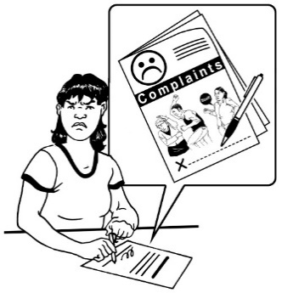
You can make a complaint to the hospital.

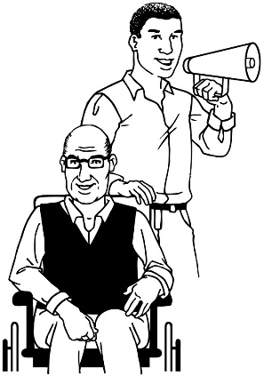
You can talk to an Advocate from the Nationwide Health and Disability Advocacy Service.

Find out how to contact the Advocacy Service on page 40 of this booklet.

You can make a complaint to the Health and Disability Commissioner.

Find out how to contact the Health and Disability Commissioner on page 36 of this booklet.

Contacts

Age Concern

Age Concern is for people over 65 years old.
It is a group that helps people and gives them information.

Website:

https://www.ageconcern.org.nz/

Phone National Office:

04 801 9338

Email:

national.office@ageconcern.org.nz

Health and Disability Commissioner

The Health and Disability Commissioner looks at complaints people make when they are unhappy with a health or disability service.

Website:

https://www.hdc.org.nz/

Phone:

0800 11 22 33

Email:

hdc@hdc.org.nz

Health Navigator New Zealand

Health Navigator has information on:
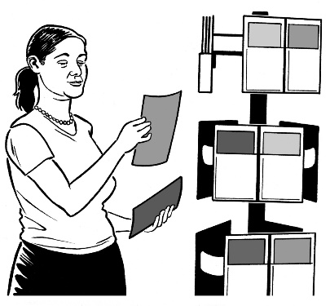
- health conditions

- medications

- support groups.

Website:

https://www.healthnavigator.org.nz/

Ministry of Health

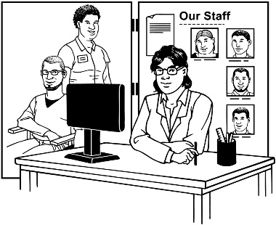
Ministry of Health has information about and services for people who have health and disability needs.

Website:

https://www.health.govt.nz/

Phone:

0800 611 116 (Healthline)

0800 855 066 (General)

Email:

info@health.govt.nz

Ministry for Pacific Peoples

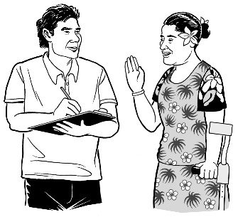
Ministry for Pacific Peoples has information for people from the Pacific Islands.

Website:

https://www.mpia.govt.nz/

Phone:

04 473 4493

Email:

contact@mpp.govt.nz

Nationwide Health and Disability Advocacy Service
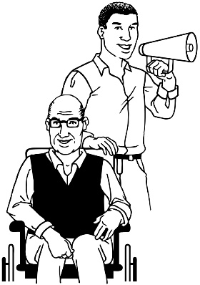

The Nationwide Health and Disability Advocacy Service can talk to you if you are unhappy with a health or disability service.

Website:

https://advocacy.org.nz/

Phone:

0800 555 050

Email:

advocacy@advocacy.org.nz

New Zealand Federation of Disability Information Centres

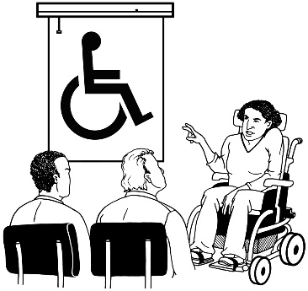
The New Zealand Federation of Disability Information Centres is a group of organisations who help with information and training to make your care better.

Website:

www.nzfdic.org.nz

Phone:

021 124 8860

Email:

admin@nzfdic.org.nz

New Zealand Video Interpreting Service

The New Zealand Video Interpreting Service can help you if you need a New Zealand Sign Language interpreter.

Website:

https://nzvis.co.nz/

Phone:

0800 4 713 713

Voice: 0800 4 877 877

Information about your rights
You can contact these organisations for information about your rights.
The Nationwide Health & Disability Advocacy Service
Free Phone: 0800 555 050

Email: advocacy@hdc.org.nz

Website: www.advocacy.org.nz

The Health and Disability
Commissioner

Phone Auckland: (09) 373 1060
Phone Wellington: (04) 494 7900

National Freephone: 0800 11 22 33

Email: hdc@hdc.org.nz

This booklet was made by the
Health and Disability Commissioner.

The information has been translated into Easy Read with advice from the Make It Easy service of People First New Zealand Inc. Ngā Tāngata Tuatahi.

Make It Easy uses images from:

- Changepeople.org

- Photosymbols.com

- Sam Corliss

All images used in this Easy Read document are subject to copyright rules and cannot be used without permission.

